**Project Design Phase-II**

**Solution Requirements (Functional & Non-functional)**

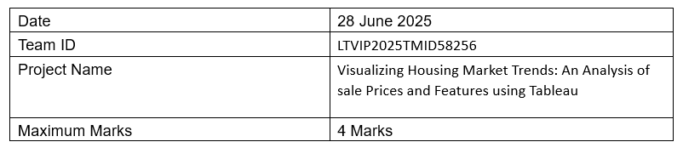

**Functional Requirements:**

Following are the functional requirements of the proposed solution.

|  |  |  |
| --- | --- | --- |
| **FR No.** | **Functional Requirement (Epic)** | **Sub Requirement (Story / Sub-Task)** |
| FR-1 | Data Collection | Upload housing dataset in CSV format |
| FR-2 | Data Preparation | Clean, filter, and transform data using Tableau Prep |
| FR-3 | KPI Visualization | Display average sale price, total records, and basement area KPIs |
| FR-4 | Feature-based Visualization | Visualize house age by renovations, bathrooms, bedrooms, and floors |
| FR-5 | Dashboard Sharing | Export or share dashboard via Tableau Public link |

**Non-functional Requirements:**

Following are the non-functional requirements of the proposed solution.

|  |  |  |
| --- | --- | --- |
| **FR No.** | **Non-Functional Requirement** | **Description** |
| NFR-1 | Usability | Dashboard should be easy to navigate and understand for all user roles |
| NFR-2 | Security | Only authorized users should upload or modify data |
| NFR-3 | Reliability | Dashboard should load consistently without failures |
| NFR-4 | Performance | Load and refresh time should be under 5 seconds for average datasets |
| NFR-5 | Availability | Dashboard must be available at all working hours without major downtime |
| NFR-6 | Scalability | Solution must support growing datasets and allow adding new visual modules |